DEVELOPING WEB APPLICATION USING NODE RED

TEAM ID: PNT2022TMID00940

1. Creating WebUI using NodeRed

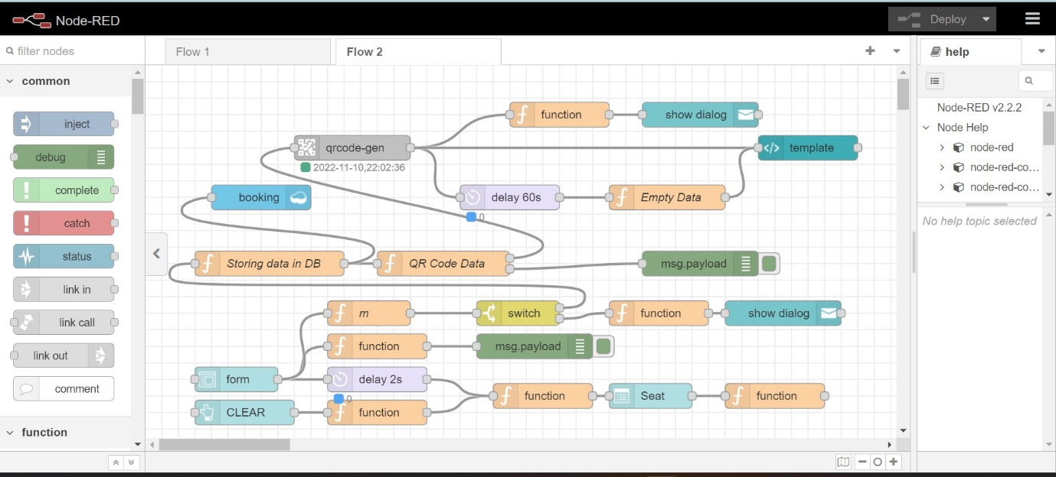

2 .Details triggered to cloudant database

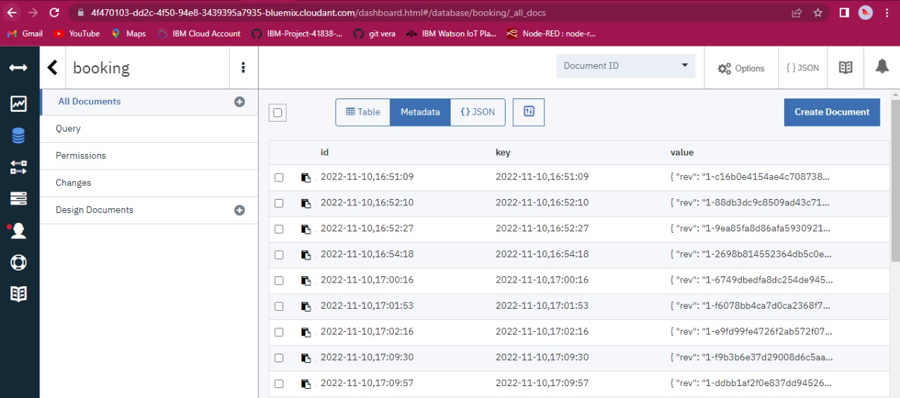

1. . Web UI Interface

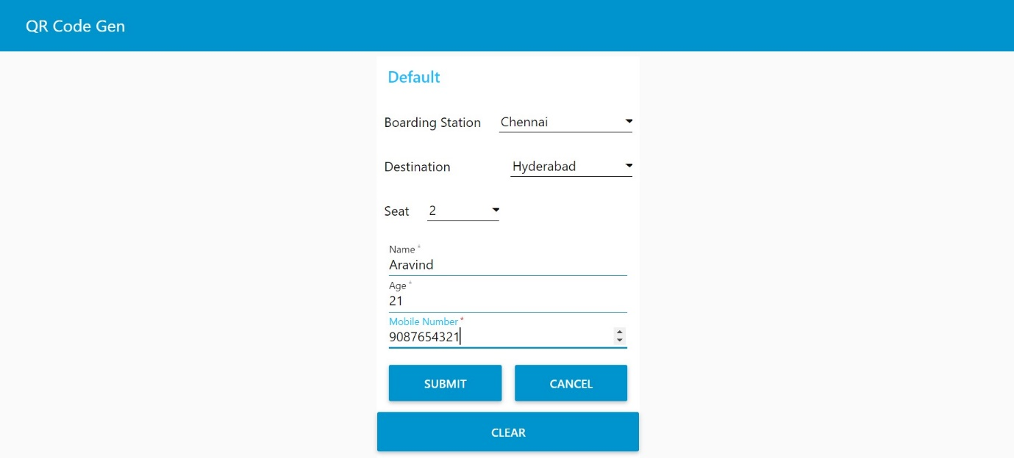

4 . A detailed view of details in cloud which is entered at web UI

